PROJECT TITLE : spi master
STUDENT NAME : kudeti shireesha
DEPARTMENT : electronics and communication engineering
SPI MASTER

1. Objective
The objective of this project is to design and functionally verify an 8-bit SPI Master at RTL level. The design generates the SPI clock, transmits serial data through MOSI, receives serial data through MISO, and provides control, status, and data access through an APB interface selected as the project specification.

2. Tools Required:
- Icarus Verilog.
- GTKWave.

3. Design Specifications
Parameter | Specification
Control interface | APB Slave interface
Data width | 8 bits
TX interface | MOSI
RX interface | MISO
SPI clock | SCLK
System clock | PCLK
Tick generator | DIVISOR = 4
Reset | Active-low presetn
TXDATA address | 0x00
RXDATA address | 0x04
STATUS address | 0x08
Example TX data | 8'h3C
Example RX data | 8'hA5
RTL language | Verilog
Simulation | Icarus Verilog
Waveform viewer | GTKWave

4. Architecture
The design is divided into an APB register/control block, tick generator, SPI transmit datapath, and SPI receive datapath.
High-level flow: APB Master → APB Registers → TX Control/Data → SPI TX → MOSI → SPI Slave → MISO → SPI RX → RXDATA → APB Readback

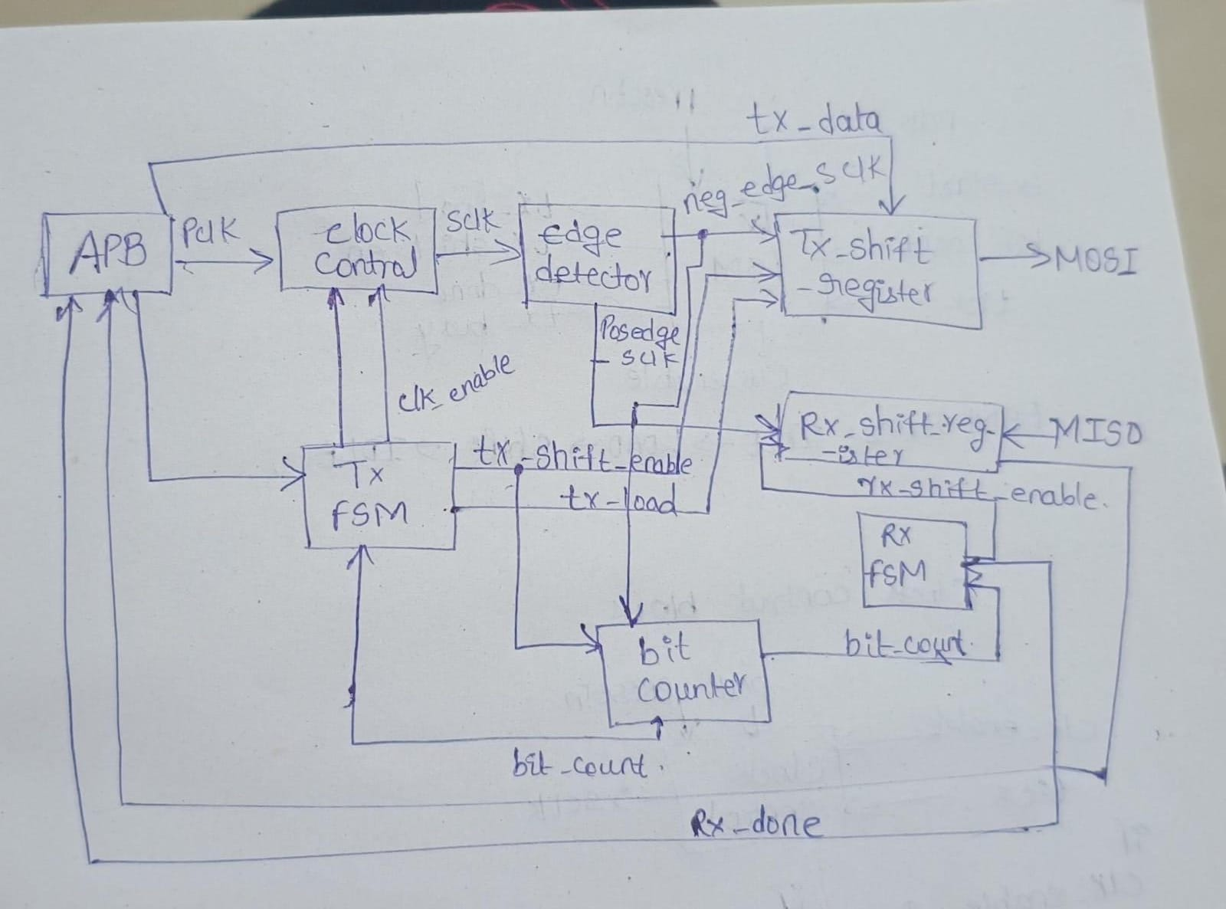

5. Microarchitecture

5.1 APB Register Block — spi_apb_regs
Interfaces the selected APB control interface with SPI logic. It decodes APB transactions, stores TX data, generates tx_start, provides RX data on PRDATA, generates PREADY, and provides status. Register map: 0x00 TXDATA, 0x04 RXDATA, 0x08 STATUS. The verified write was address 0x00 with data 0x0000003C.
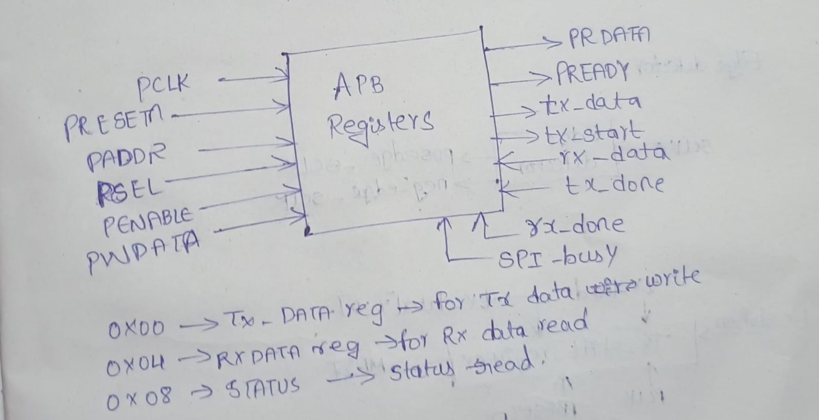
module spi_apb_regs #(
parameter DATA_WIDTH = 8
) (
// ---------------- APB slave interface ----------------
input wire PCLK,
input wire PRESETn,
input wire [31:0] PADDR,
input wire PWRITE,
input wire PSEL,
input wire PENABLE,
input wire [31:0] PWDATA,
output reg [31:0] PRDATA,
output reg PREADY,

// ---------------- uart_tx interface ----------------
output reg [DATA_WIDTH-1:0] tx_data,
output reg tx_start,
input wire spi_busy,

input wire [DATA_WIDTH-1:0] rx_data,
input wire tx_done,
input wire rx_done
);
// -------------------------------------------------------------------
// Register offsets
// -------------------------------------------------------------------
localparam ADDR_TXDATA = 32'h00;
localparam ADDR_RXDATA = 32'h04;
localparam ADDR_STATUS = 32'h08;
localparam ADDR_CONTROL = 32'h0C;
localparam ST_IDLE = 2'b00;
localparam ST_SETUP = 2'b01;
localparam ST_ACCESS = 2'b10;
reg [1:0] state;
wire is_txdata = (PADDR == ADDR_TXDATA);
wire is_rxdata = (PADDR == ADDR_RXDATA);
wire is_control = (PADDR == ADDR_CONTROL);
wire txdata_write_stall = PWRITE && is_txdata && spi_busy;

always @(*) begin
if (state == ST_ACCESS)
PREADY = !txdata_write_stall;
else
PREADY = 1'b0;
end

// -------------------------------------------------------------------
// FSM + register actions
// -------------------------------------------------------------------
always @(posedge PCLK) begin
if (!PRESETn) begin
state <= ST_IDLE;
tx_data <= 0;
tx_start <= 1'b0;
end else begin
tx_start <= 1'b0;
case (state)
ST_IDLE: begin
if (PSEL && !PENABLE)
state <= ST_SETUP;
end
ST_SETUP: begin
// Spec: SETUP lasts exactly one cycle, always moving
// to ACCESS on the next edge.
state <= ST_ACCESS;
end
ST_ACCESS: begin
if (PREADY) begin
// Transfer completes THIS cycle (access_complete
// is true right now, since PREADY is high while
// we're still in ST_ACCESS evaluating it).
if (PWRITE) begin
if (is_txdata) begin
tx_data <= PWDATA[DATA_WIDTH-1:0];
tx_start <= 1'b1;
end else if (is_control) begin
// bit0: write-1-to-clear rx_overrun.
// Handled by the separate rx_overrun_ack_r
// process below (same one-shot pattern as
// tx_start / fifo_rd_en).
end
end
else begin
end
state <= ST_IDLE;
end
end

default: state <= ST_IDLE;
endcase
end
end
always @(*) begin
PRDATA = 32'h0;
if (state == ST_ACCESS && !PWRITE) begin
case (PADDR)
ADDR_RXDATA:
PRDATA = {{(32-DATA_WIDTH){1'b0}}, rx_data};

ADDR_STATUS:
PRDATA = {
29'd0,
spi_busy,
rx_done,
tx_done
};
default: PRDATA = 32'h0;
endcase
end
end
endmodule

5.2 Tick Generator — tick_gen
Generates a slower timing pulse from PCLK. The project uses DIVISOR = 4. The tick is used by SPI timing/control logic.
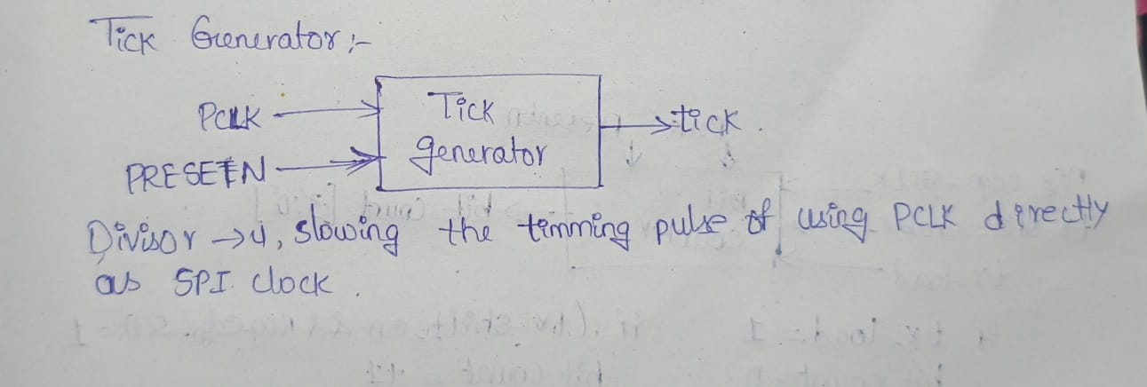
// =============================================================================
module tick_gen #(
parameter DIVISOR = 434 // clk cycles per tick; must be >= 2
) (
input wire clk,
input wire rst_n, // active-low synchronous reset
output wire tick // single-cycle pulse, once every DIVISOR cycles
);
localparam CNT_WIDTH = $clog2(DIVISOR);
reg [CNT_WIDTH-1:0] count;
assign tick = (count == DIVISOR - 1);
always @(posedge clk) begin
if (!rst_n) begin
count <= 0;
end else if (count == DIVISOR - 1) begin
count <= 0;
end else begin
count <= count + 1'b1;
end
end
endmodule

5.3 SPI TX Top — spi_tx_top
Integrates clock control, edge detector, TX shift register, bit counter, and TX FSM. Sequence: tx_start → load → SCLK generation → shifting → 8-bit count → tx_done → IDLE.

//----------------------------------------------------------
module spi_tx_top(
input wire pclk,
input wire presetn,
input wire tx_start,
input wire [7:0] tx_data,
input wire tick,
output wire mosi,
output wire sclk,
output wire tx_done,
output wire tx_busy
);
wire tx_load;
wire tx_shift_en;
wire clock_enable;
wire [3:0] bit_count;
wire posedge_sclk;
wire negedge_sclk;
//--------------------------------------------
// Clock Control
//--------------------------------------------
spi_clock_control u_clock(
.pclk (pclk),
.presetn (presetn),
.tick (tick),
.clock_enable (clock_enable),
.sclk (sclk)
);
//--------------------------------------------
// Edge Detector
//--------------------------------------------
spi_edge_detector u_edge(
.pclk (pclk),
.presetn (presetn),
.sclk (sclk),
.posedge_sclk (posedge_sclk),
.negedge_sclk (negedge_sclk)
);
//--------------------------------------------
// TX Shift Register
//--------------------------------------------
spi_tx_shift_register u_shift(
.pclk (pclk),
.presetn (presetn),
.negedge_sclk (negedge_sclk),
.tx_load (tx_load),
.tx_shift_en (tx_shift_en),
.tx_data (tx_data),
.mosi (mosi)
);
//--------------------------------------------
// Bit Counter
//--------------------------------------------
spi_bit_counter u_counter(
.pclk (pclk),
.presetn (presetn),
.negedge_sclk (negedge_sclk),
.tx_load (tx_load),
.tx_shift_en (tx_shift_en),
.bit_count (bit_count)
);
//--------------------------------------------
// TX FSM
//--------------------------------------------
spi_tx_fsm u_fsm(
.pclk (pclk),
.presetn (presetn),
.tx_start (tx_start),
.tick (tick),
.bit_count (bit_count),
.tx_load (tx_load),
.tx_shift_en (tx_shift_en),
.clock_enable (clock_enable),
.tx_done (tx_done),
.tx_busy (tx_busy)
);
endmodule

5.4 TX FSM — spi_tx_fsm
Uses IDLE, LOAD, and SHIFT states. IDLE waits for tx_start. LOAD loads TX data and activates the transaction. SHIFT enables clocking and serial shifting. When bit_count reaches 8, tx_done pulses and the FSM returns to IDLE.

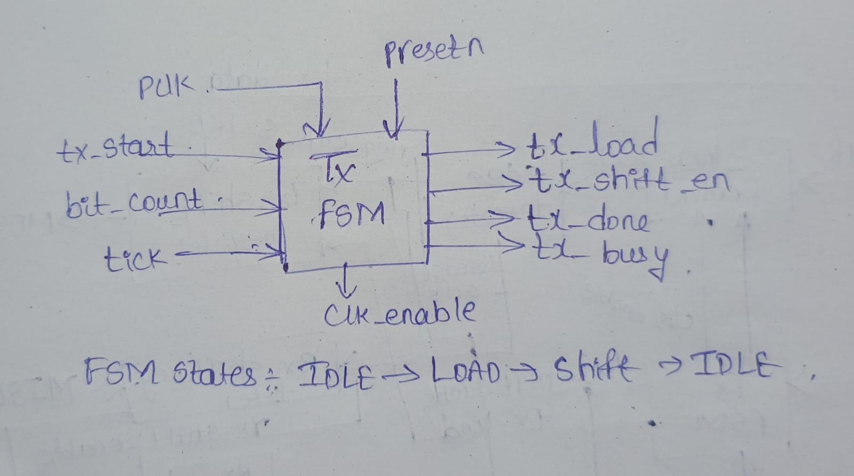
module spi_tx_fsm(
input wire pclk,
input wire presetn,
input wire tx_start,
input wire tick,
input wire [3:0] bit_count,
output reg tx_load,
output reg tx_shift_en,
output reg clock_enable,
output reg tx_done,
output reg tx_busy
);

localparam IDLE = 2'b00;
localparam LOAD = 2'b01;
localparam SHIFT = 2'b10;

reg [1:0] current_state;
reg [1:0] next_state;

//----------------------------------------
// State Register
//----------------------------------------

always @(posedge pclk or negedge presetn)
begin
if(!presetn)
current_state <= IDLE;
else
current_state <= next_state;
end

//----------------------------------------
// Next State Logic
//----------------------------------------

always @(*)
begin

case(current_state)

IDLE:
begin
if(tx_start)
next_state = LOAD;
else
next_state = IDLE;
end

LOAD:
begin
next_state = SHIFT;
end

SHIFT:
begin
if(bit_count == 4'd8)
next_state = IDLE;
else
next_state = SHIFT;
end

default:
next_state = IDLE;

endcase

end

//----------------------------------------
// Output Logic
//----------------------------------------

always @(*)
begin

tx_load = 1'b0;
tx_shift_en = 1'b0;
clock_enable = 1'b0;
tx_done = 1'b0;
tx_busy = 1'b0;

case(current_state)

IDLE:
begin
tx_busy = 1'b0;
end

LOAD:
begin
tx_load = 1'b1;
clock_enable = 1'b1;
tx_busy = 1'b1;
end

SHIFT:
begin
clock_enable = 1'b1;
tx_shift_en = 1'b1;
tx_busy = 1'b1;

if(bit_count == 4'd8)
begin
tx_done = 1'b1;
clock_enable = 1'b1;
end
end
default:
begin
end
endcase
end
endmodule

5.5 SPI Clock Control
Generates SCLK from PCLK, tick, and clock_enable. SCLK toggles during an active transaction and stops afterward.
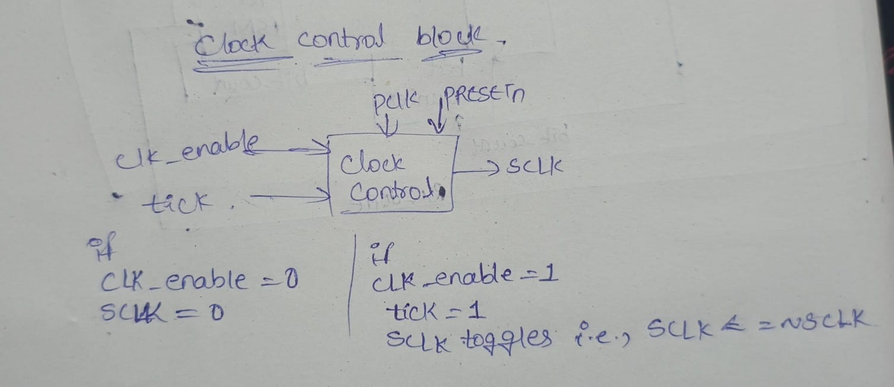

module spi_clock_control(
input wire pclk,
input wire presetn,
input wire tick,
input wire clock_enable,
output reg sclk
);
always @(posedge pclk or negedge presetn)
begin

if(!presetn)
sclk <= 1'b0;
else if(!clock_enable)
sclk <= 1'b0;
else if(tick)
sclk <= ~sclk;
end
endmodule

5.6 SPI Edge Detector
Monitors SCLK and produces posedge_sclk and negedge_sclk indications used by the SPI datapath.
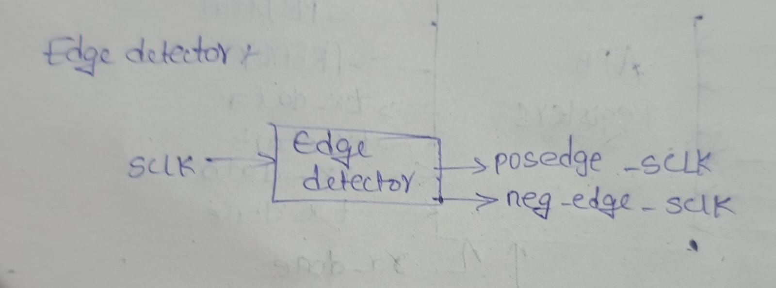
module spi_edge_detector(
input wire pclk,
input wire presetn,
input wire sclk,
output wire posedge_sclk,
output wire negedge_sclk
);
reg sclk_d;
always @(posedge pclk or negedge presetn)
begin
if(!presetn)
sclk_d <= 1'b0;
else
sclk_d <= sclk;
end
assign posedge_sclk = (~sclk_d) & sclk;
assign negedge_sclk = sclk_d & (~sclk);
endmodule

5.7 TX Shift Register
Stores the 8-bit transmit value and produces the serial stream on MOSI. The verified TX value was 8'h3C.
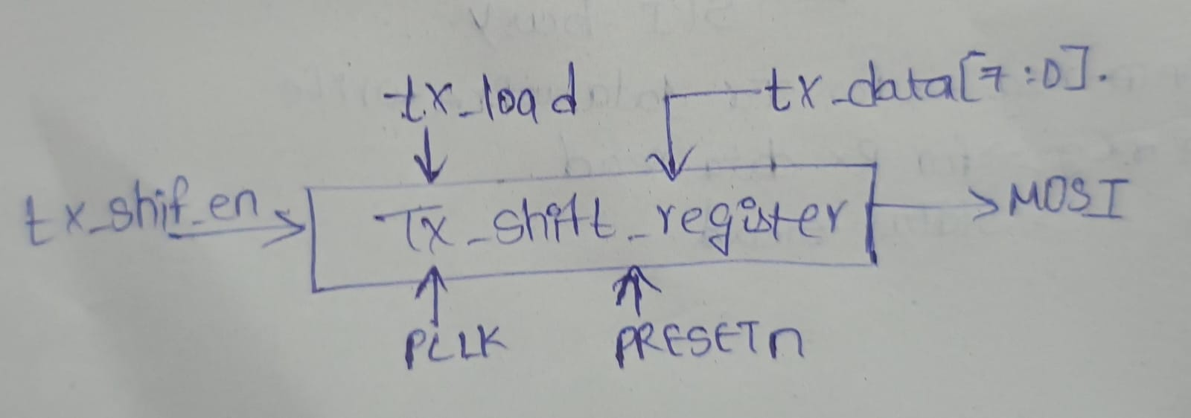
module spi_tx_shift_register(
input wire pclk,
input wire presetn,
input wire negedge_sclk,
input wire tx_load,
input wire tx_shift_en,
input wire [7:0] tx_data,
output wire mosi
);
reg [7:0] shift_reg;
assign mosi = shift_reg[7];
always @(posedge pclk or negedge presetn)
begin
if(!presetn)
begin
shift_reg <= 8'b00000000;
end
else if(tx_load)
begin
shift_reg <= tx_data;
end
else if(tx_shift_en && negedge_sclk)
begin
shift_reg <= {shift_reg[6:0], 1'b0};
end
end
endmodule

5.8 Bit Counter
Tracks transmitted bits. GTKWave showed the counter progressing from 0 through 8, confirming an 8-bit transfer.
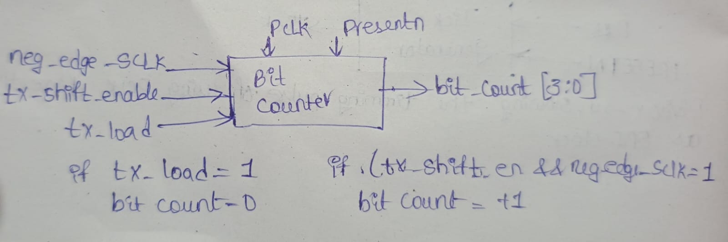
module spi_bit_counter(
input wire pclk,
input wire presetn,
input wire negedge_sclk,
input wire tx_load,
input wire tx_shift_en,
output reg [3:0] bit_count
);
always @(posedge pclk or negedge presetn)
begin
if(!presetn)
begin
bit_count <= 4'd0;
end
else if(tx_load)
begin
bit_count <= 4'd0;
end
else if(tx_shift_en && negedge_sclk)
begin
bit_count <= bit_count + 1'b1;
end
end
endmodule

5.9 RX Top — spi_rx_top
Captures serial data from MISO during the SPI transaction. The simulated slave supplied A5 (1010_0101). After 8 bits, rx_data became 8'hA5 and rx_done asserted.
module spi_rx_top(
input wire pclk,
input wire presetn,
input wire rx_start,
input wire tick,
input wire sclk,
input wire miso,
output wire [7:0] rx_data,
output wire rx_done
);
wire rx_shift_en;
wire [3:0] bit_count;
wire posedge_sclk;
wire negedge_sclk;

//--------------------------------------------------
// Edge Detector
//--------------------------------------------------
spi_edge_detector u_edge(
.pclk (pclk),
.presetn (presetn),
.sclk (sclk),
.posedge_sclk (posedge_sclk),
.negedge_sclk (negedge_sclk)
);
//--------------------------------------------------
// RX Shift Register
//--------------------------------------------------
spi_rx_shift_register u_shift(
.pclk (pclk),
.presetn (presetn),
.posedge_sclk (posedge_sclk),
.rx_shift_en (rx_shift_en),
.miso (miso),
.rx_data (rx_data)
);
//--------------------------------------------------
// Bit Counter
//--------------------------------------------------
spi_bit_counter u_counter(
.pclk (pclk),
.presetn (presetn),
.negedge_sclk (negedge_sclk),
.tx_load (1'b0),
.tx_shift_en (rx_shift_en),
.bit_count (bit_count)
);
//--------------------------------------------------
// RX FSM
//--------------------------------------------------
spi_rx_fsm u_fsm(
.pclk (pclk),
.presetn (presetn),
.rx_start (rx_start),
.tick (tick),
.bit_count (bit_count),
.rx_shift_en (rx_shift_en),
.rx_done (rx_done)
);
endmodule

5.10 RX FSM

module spi_rx_fsm(
input wire pclk,
input wire presetn,
input wire rx_start,
input wire tick,
input wire [3:0] bit_count,
output reg rx_shift_en,
output reg rx_done
);
//--------------------------------------------------
// State Encoding
//--------------------------------------------------
parameter IDLE = 2'b00;
parameter SHIFT = 2'b01;
parameter DONE = 2'b10;
reg [1:0] current_state;
reg [1:0] next_state;
//--------------------------------------------------
// State Register
//--------------------------------------------------
always @(posedge pclk or negedge presetn)
begin
if(!presetn)
current_state <= IDLE;
else
current_state <= next_state;
end
//--------------------------------------------------
// Next State Logic
//--------------------------------------------------
always @(*)
begin
case(current_state)
IDLE :
begin
if(rx_start)
next_state = SHIFT;
else
next_state = IDLE;
end
SHIFT :
begin
// Stay in SHIFT until counter reaches 7
if(bit_count == 4'd8)
next_state = DONE;
else
next_state = SHIFT;
end
DONE :
next_state = IDLE;

default :
next_state = IDLE;
endcase
end
//--------------------------------------------------
// Output Logic
//--------------------------------------------------
always @(*)
begin
rx_shift_en = 1'b0;
rx_done = 1'b0;
case(current_state)
IDLE :
begin
rx_shift_en = 1'b0;
rx_done = 1'b0;
end
SHIFT :
begin
rx_shift_en = (bit_count < 4'd8);
rx_done = 1'b0;
end
DONE :
begin
rx_shift_en = 1'b0;
rx_done = 1'b1;
end
endcase
end
endmodule

5.11 RX Shift register
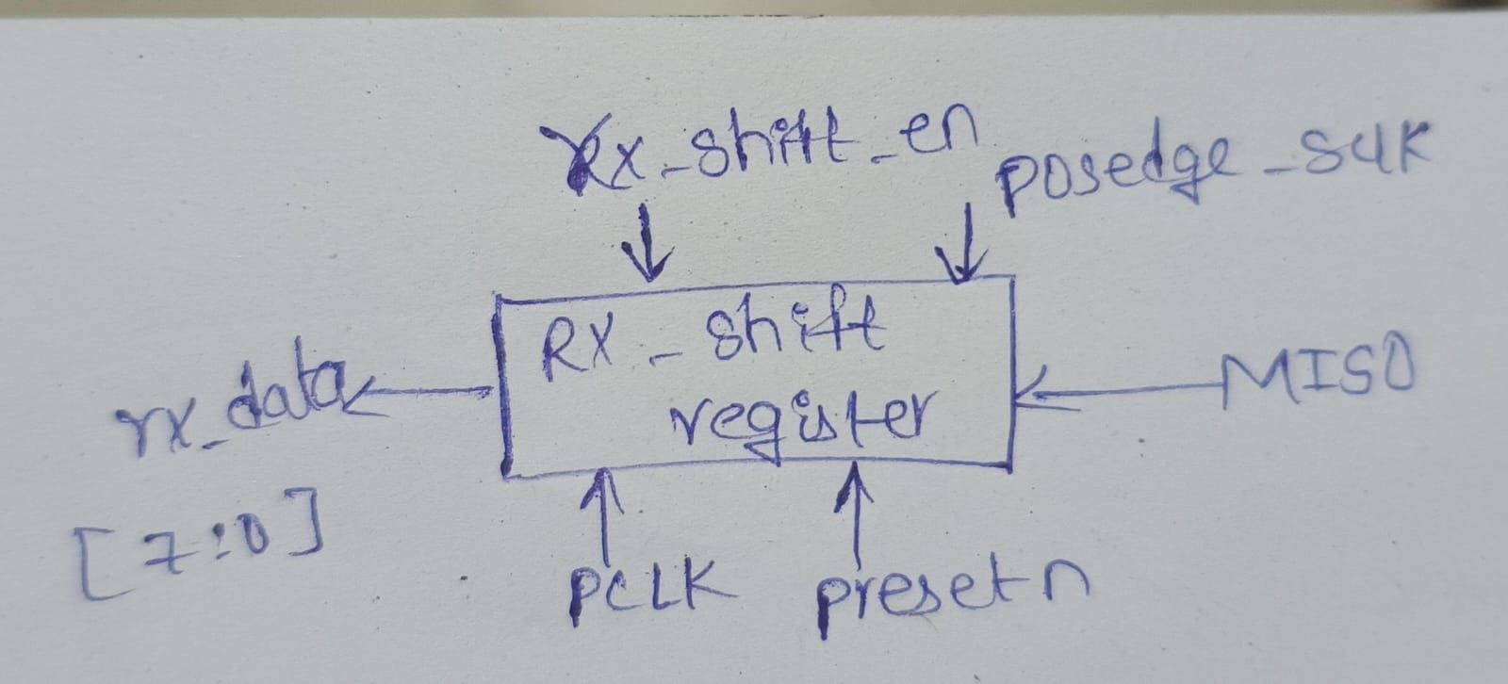
module spi_rx_shift_register(
input wire pclk,
input wire presetn,
input wire posedge_sclk,
input wire rx_shift_en,
input wire miso,
output wire [7:0] rx_data
);
reg [7:0] shift_reg;
assign rx_data = shift_reg;
always @(posedge pclk or negedge presetn)
begin
if(!presetn)
begin
shift_reg <= 8'b00000000;
end
else if(rx_shift_en && posedge_sclk)
begin
shift_reg <= {shift_reg[6:0], miso};
end
end
endmodule

5.11 Master Top

module spi_master_top(
// -----------------------------------------
// System Clock and Reset
// -----------------------------------------
input wire pclk,
input wire presetn,
// -----------------------------------------
// APB Slave Interface
// -----------------------------------------
input wire [31:0] paddr,
input wire pwrite,
input wire psel,
input wire penable,
input wire [31:0] pwdata,
output wire [31:0] prdata,
output wire pready,
// -----------------------------------------
// SPI Interface
// -----------------------------------------
input wire miso,
output wire mosi,
output wire sclk
);
//--------------------------------------------------
// Internal Signals
//--------------------------------------------------
wire [7:0] tx_data;
wire tx_start;
wire [7:0] rx_data;
wire tx_done;
wire rx_done;
wire tick;
// TX busy signal
wire tx_busy;
// SPI busy signal going to APB
wire spi_busy;
//--------------------------------------------------
// SPI Busy Connection
//--------------------------------------------------
assign spi_busy = tx_busy;
//--------------------------------------------------
// RX starts along with TX transaction.
//--------------------------------------------------
wire rx_start;
assign rx_start = tx_start;
//--------------------------------------------------
// APB Registers
//--------------------------------------------------
spi_apb_regs #(
.DATA_WIDTH(8)
) u_apb_regs (
.PCLK (pclk),
.PRESETn (presetn),
.PADDR (paddr),
.PWRITE (pwrite),
.PSEL (psel),
.PENABLE (penable),
.PWDATA (pwdata),
.PRDATA (prdata),
.PREADY (pready),
.tx_data (tx_data),
.tx_start (tx_start),
.spi_busy (spi_busy),
.rx_data (rx_data),
.tx_done (tx_done),
.rx_done (rx_done)
);
//--------------------------------------------------
// Tick Generator
//--------------------------------------------------
tick_gen #(
.DIVISOR(4)
) u_tick_gen (
.clk (pclk),
.rst_n (presetn),
.tick (tick)
);
//--------------------------------------------------
// TX Top
//--------------------------------------------------
spi_tx_top u_tx (
.pclk (pclk),
.presetn (presetn),
.tx_start (tx_start),
.tx_data (tx_data),
.tick (tick),
.mosi (mosi),
.sclk (sclk),
.tx_done (tx_done),
.tx_busy (tx_busy)
);
//--------------------------------------------------
// RX Top
//--------------------------------------------------
spi_rx_top u_rx (
.pclk (pclk),
.presetn (presetn),
.rx_start (rx_start),
.tick (tick),
.sclk (sclk),
.miso (miso),
.rx_data (rx_data),
.rx_done (rx_done)
);
endmodule

Master Testbench:
`timescale 1ns/1ps
module spi_master_top_tb;
reg pclk;
reg presetn;
//--------------------------------------
// APB Signals
//--------------------------------------
reg [31:0] paddr;
reg pwrite;
reg psel;
reg penable;
reg [31:0] pwdata;
wire [31:0] prdata;
wire pready;
//--------------------------------------
// SPI Signals
//--------------------------------------
reg miso;
wire mosi;
wire sclk;
//--------------------------------------
// DUT
//--------------------------------------
spi_master_top dut (
.pclk (pclk),
.presetn (presetn),
// APB Interface
.paddr (paddr),
.pwrite (pwrite),
.psel (psel),
.penable (penable),
.pwdata (pwdata),
.prdata (prdata),
.pready (pready),
// SPI Interface
.miso (miso),
.mosi (mosi),
.sclk (sclk)
);
//--------------------------------------
// Clock Generation
//--------------------------------------
always #5 pclk = ~pclk;
//--------------------------------------
// Wave Dump
//--------------------------------------
initial begin
$dumpfile("spi_master_top.vcd");
// Dump complete testbench + DUT hierarchy
$dumpvars(0, spi_master_top_tb);
end
//--------------------------------------
// APB WRITE TASK
//--------------------------------------
task apb_write;
input [31:0] addr;
input [31:0] data;
begin
//----------------------------------
// SETUP Phase
//----------------------------------
@(posedge pclk);
paddr = addr;
pwdata = data;
pwrite = 1'b1;
psel = 1'b1;
penable = 1'b0;
//----------------------------------
// ACCESS Phase
//----------------------------------
@(posedge pclk);
penable = 1'b1;
//----------------------------------
// Wait for PREADY
//----------------------------------
while (!pready)
@(posedge pclk);
//----------------------------------
// Return to IDLE
//----------------------------------
@(posedge pclk);
psel = 1'b0;
penable = 1'b0;
pwrite = 1'b0;
paddr = 32'h00000000;
pwdata = 32'h00000000;
end
endtask
//--------------------------------------
// APB READ TASK
//--------------------------------------
task apb_read;
input [31:0] addr;
begin
//----------------------------------
// SETUP Phase
//----------------------------------
@(posedge pclk);
paddr = addr;
pwrite = 1'b0;
psel = 1'b1;
penable = 1'b0;
//----------------------------------
// ACCESS Phase
//----------------------------------
@(posedge pclk);
penable = 1'b1;
//----------------------------------
// Wait for PREADY
//----------------------------------
while (!pready)
@(posedge pclk);
//----------------------------------
// Return to IDLE
//----------------------------------
@(posedge pclk);
psel = 1'b0;
penable = 1'b0;
paddr = 32'h00000000;
end
endtask
//--------------------------------------
// Test
//--------------------------------------
initial begin
//----------------------------------
// Initial Values
//----------------------------------
pclk = 1'b0;
presetn = 1'b0;
paddr = 32'h00000000;
pwrite = 1'b0;
psel = 1'b0;
penable = 1'b0;
pwdata = 32'h00000000;
miso = 1'b0;
//----------------------------------
// Reset
//----------------------------------
#20;
presetn = 1'b1;
//----------------------------------
// APB WRITE
// TXDATA = 8'h3C
// Address = 0x00
//----------------------------------
apb_write(
32'h00000000,
32'h0000003C
);
//----------------------------------
// Slave sends A5 on MISO
// A5 = 1010_0101
//----------------------------------
miso = 1'b1;
@(negedge sclk) miso = 1'b0;
@(negedge sclk) miso = 1'b1;
@(negedge sclk) miso = 1'b0;
@(negedge sclk) miso = 1'b0;
@(negedge sclk) miso = 1'b1;
@(negedge sclk) miso = 1'b0;
@(negedge sclk) miso = 1'b1;
//----------------------------------
// Wait for SPI Transaction
//----------------------------------
#1000;
//----------------------------------
// APB READ RXDATA
// Address = 0x04
//----------------------------------
apb_read(32'h00000004);
//----------------------------------
// End Simulation
//----------------------------------
#100;
$finish;
end
endmodule

5.12 RXDATA / APB Readback
Makes received data available through RXDATA. An APB read at 0x04 returns the received byte, zero-extended to 32 bits. Verified PRDATA = 32'h000000A5..

6. Verification Results
Check | Observation | Result
APB Write | 0x00 write with 0x0000003C | PASS
SPI TX | tx_busy asserted; serial transfer occurred | PASS
SCLK | SPI clock pulses observed | PASS
Bit Count | 0 → 8 | PASS
TX Done | Completion pulse observed | PASS
SPI RX | MISO supplied A5 and RX captured it | PASS
RX Data | rx_data = 8'hA5 | PASS
RX Done | Completion pulse observed | PASS
APB Read | Read at 0x04 | PASS
PRDATA | 32'h000000A5 during RX read | PASS

7. Waveform-Based Verification
The design was verified primarily through GTKWave.The waveforms confirmed the expected relationship between APB control, SPI clocking, serial transmission, serial reception, and APB readback. Signals verified:
- APB: PCLK, PRESETn, PSEL, PENABLE, PWRITE, PADDR, PWDATA, PREADY, PRDATA.
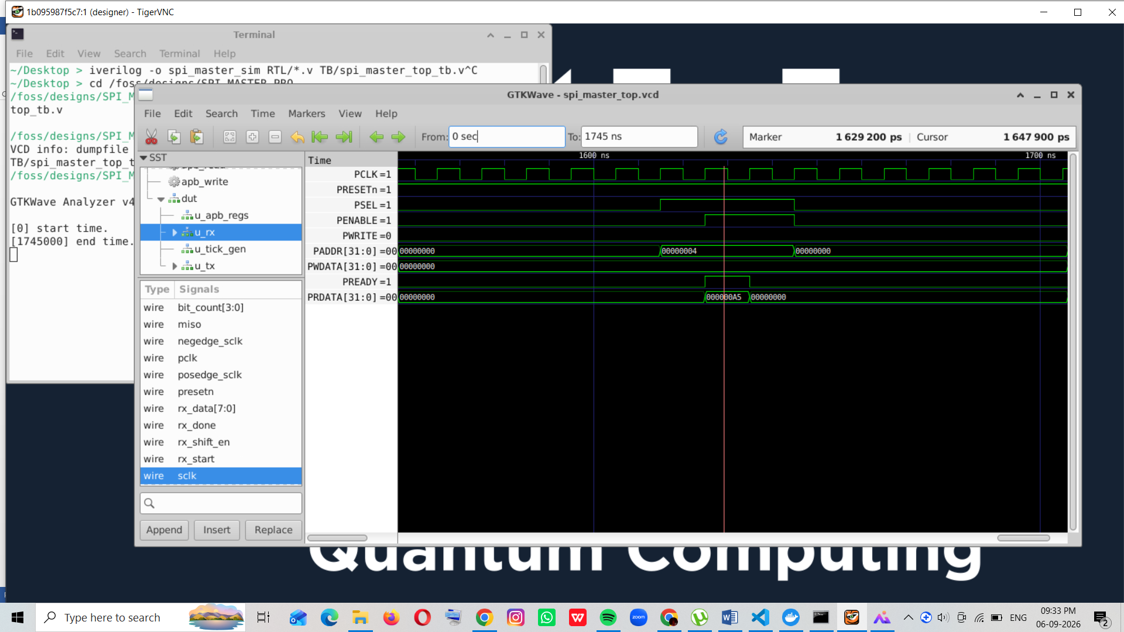
At address 0x04 RX data=A5

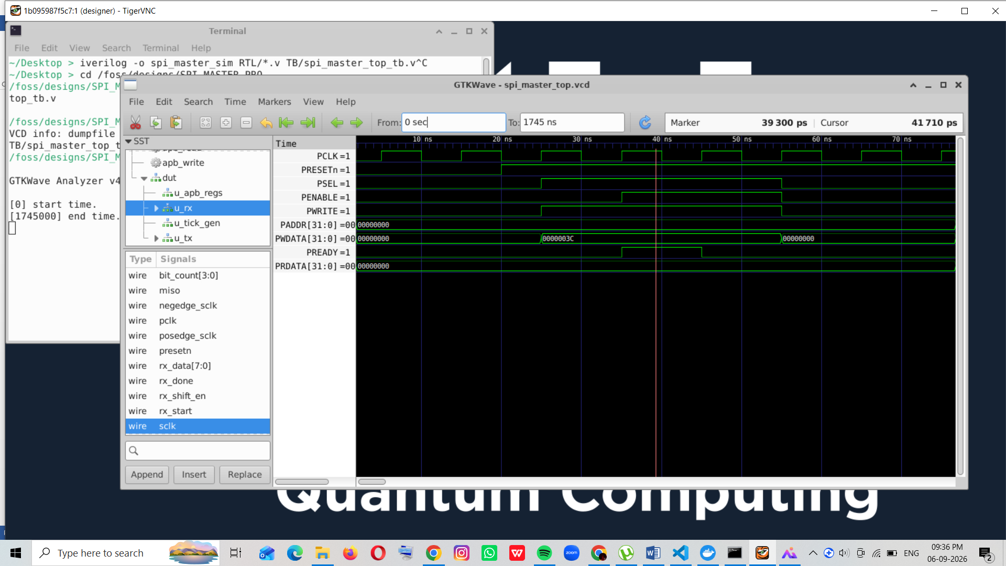
At address 0x00 TX data=3C

- SPI: SCLK, MOSI, MISO.

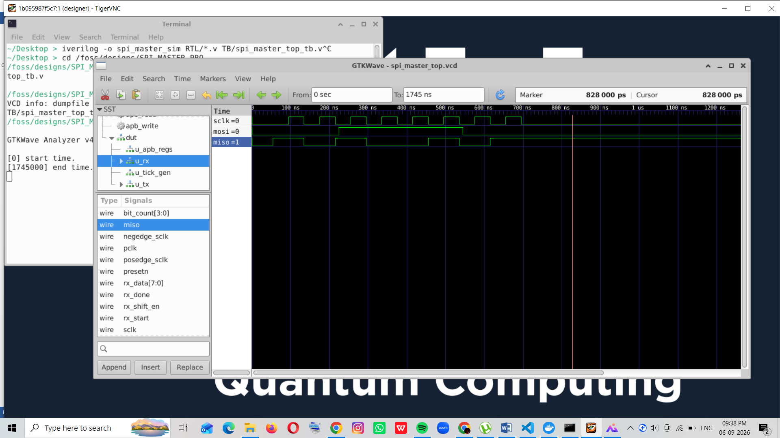
- TX: tx_start, tx_load, tx_shift_en, spi_busy, tx_done, bit_count.

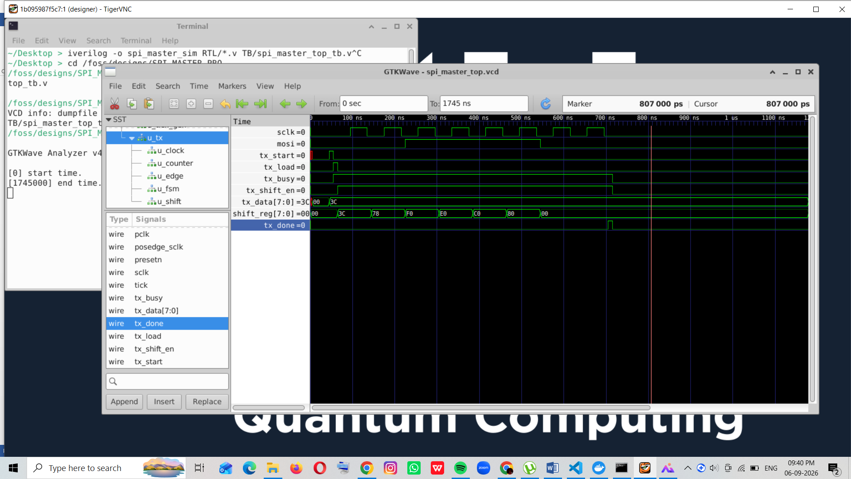

RX: rx_start, rx_shift_en, rx_data, rx_done.

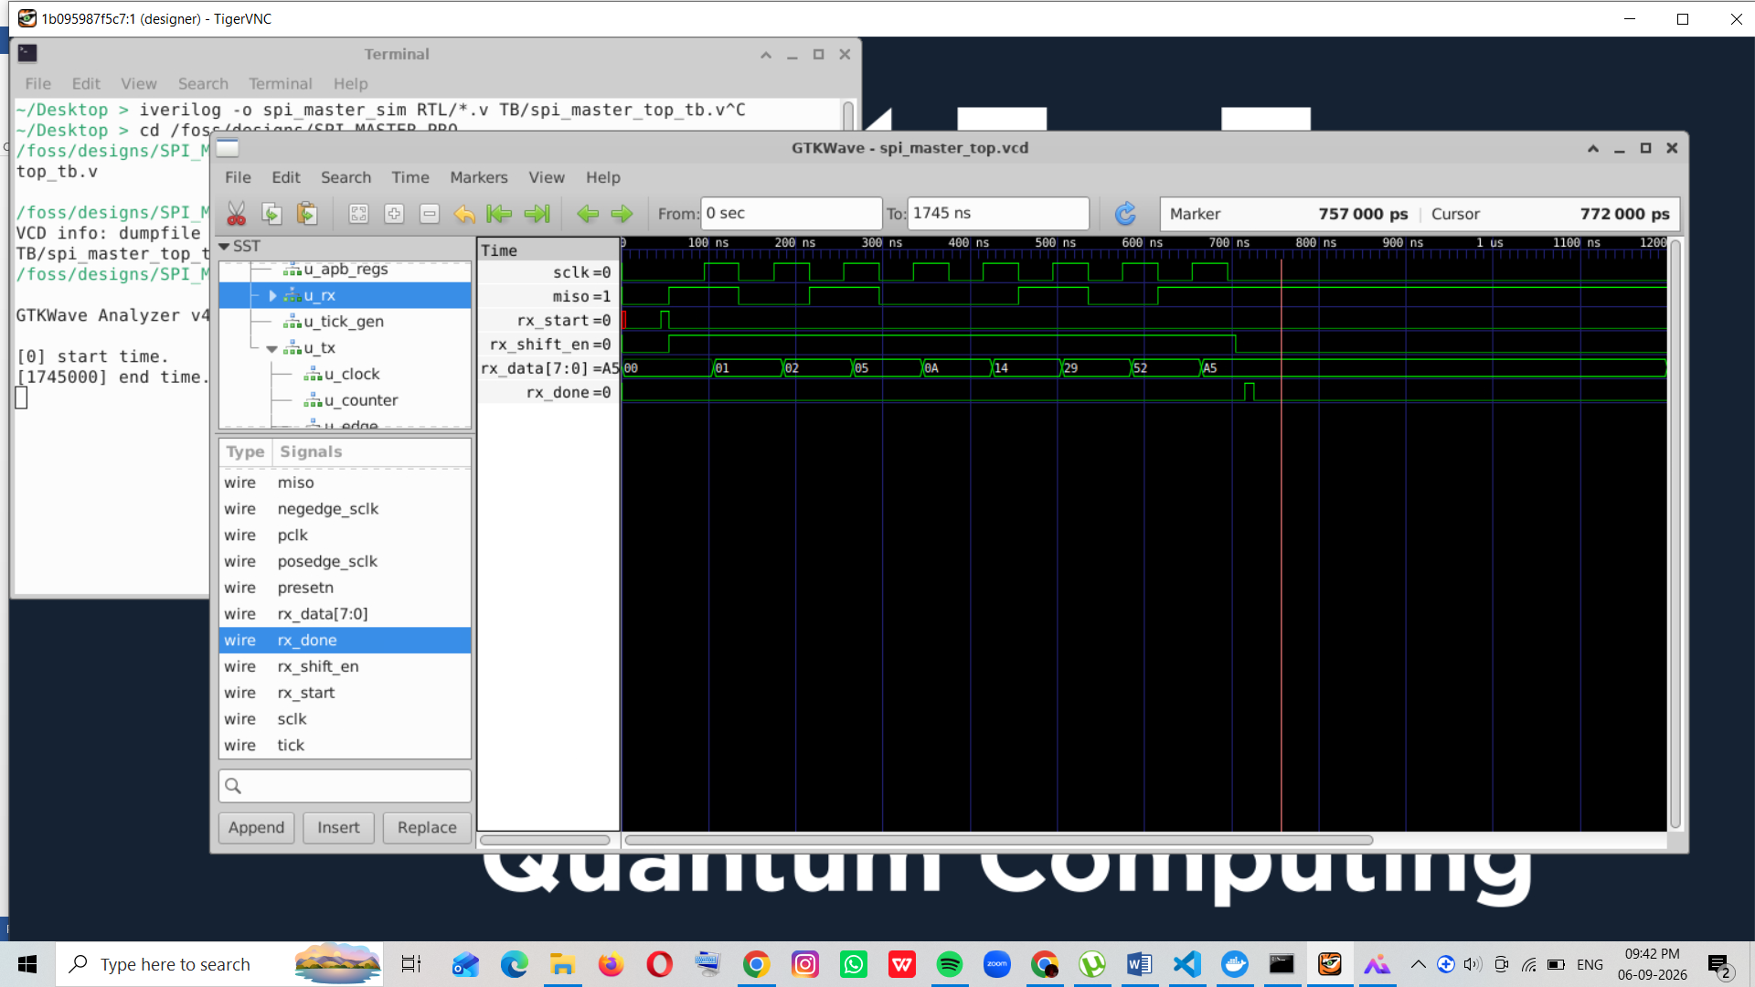
- Clock control:pclk,present,clock_enable,tick,sclk

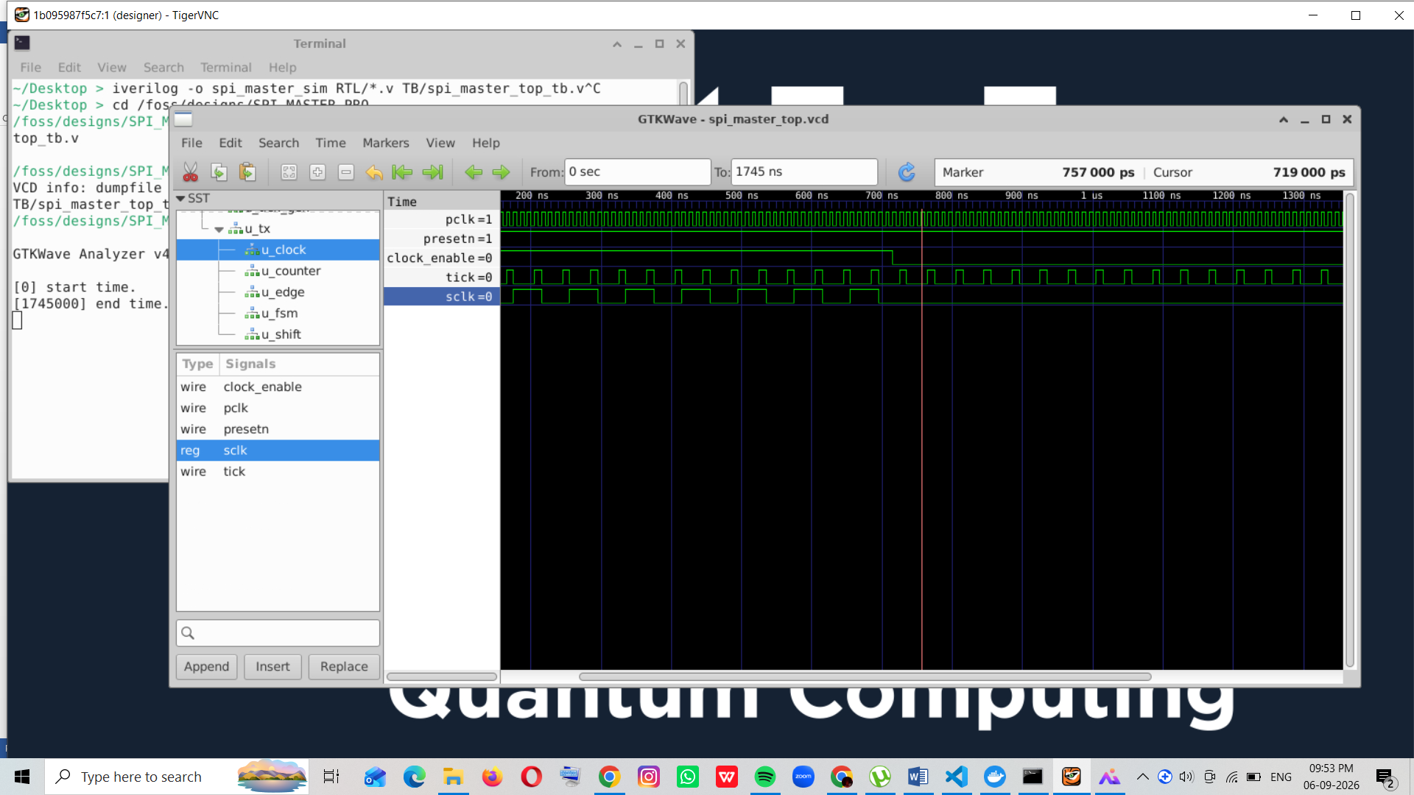

8. Final Verification Result
The complete APB-to-SPI-to-APB transaction was successfully verified.
TX Data = 8'h3C → RX Data = 8'hA5 → PRDATA = 32'h000000A5

9. Conclusion
An 8-bit SPI Master was successfully designed and functionally verified at RTL level. The design correctly performs serial transmission through MOSI, serial reception through MISO, SPI clock generation, bit counting, completion detection, and data readback.APB was selected as the project's control and register-access specification, enabling TX data writes and RX data reads.The RTL has passed the current functional verification stage.

